BAHRIA UNIVERSITY (KARACHI CAMPUS)
Computer Programming (CSC - 113)
Assignment 01
Fall 2022

Class: BSE 1B Shift: Morning
Course Instructor: MUHAMMAD FAISAL Submission: 06 Oct 2022
Date: 24 Nov 2022 Marks: 05 Points
Student Name: ABDULLAH Registration #: 02131222099



[CLO-3]

Question No 01: Write a C# program to find that a person is allowed to sit in BSE-1. He is allowed if he belongs to BUKC, and he is the student of First semester and he is a student of Software Engineering.
Solution:
Input:
using System;

namespace Abdullah_CP_Assignment_1
{
class Program
{
static void Main(string[] args)
{
string department = "BSE";
string departmentIn;
string semester = "1st";
string semesterIn;
string campus = "BUKC";
string campusIn;

Console.WriteLine("\t-Student Data Check for Entry-");
Console.WriteLine("-Are you from Bahria University?");
Console.WriteLine("\tPress Y for Yes, N for No");
string opt = Console.ReadLine();
if (opt == "Y")
{
Console.WriteLine("-From which Campus?");
campusIn = Console.ReadLine();
Console.WriteLine("-What is Your Department?");
departmentIn = Console.ReadLine();
Console.WriteLine("-In which semester you are?");
semesterIn = Console.ReadLine();

if (campus == campusIn && department == departmentIn && semester == semesterIn)
{
Console.WriteLine("You are allow to Enter, have a Nice Day");
}
else
{
Console.WriteLine("Sorry you are not allow to Enter BUKC");
}
}
else
{
Console.WriteLine("Sorry You are not allow to enter Bahria University");
}
}
}
}
Output:
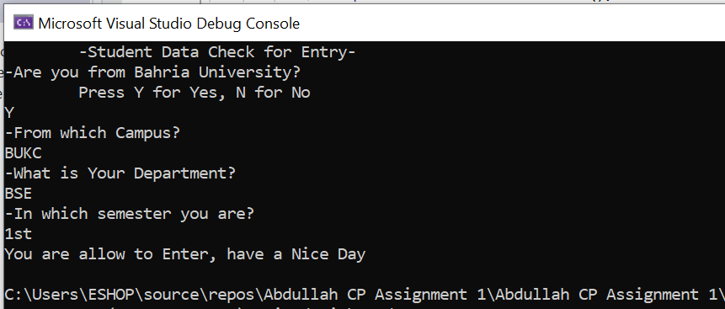
Question No 02: Write a C# program to print number of days in given month using switch-case.
Solution:
Input:
using System;

namespace Abdullah_CP_Assignment_1
{
class Program
{
static void Main(string[] args)
{
string monthName;
Console.WriteLine("Enter Month Name:");
monthName = Console.ReadLine();
switch (monthName)
{
case "Jan":
Console.WriteLine("{0} has 31 days", monthName);
break;
case "Feb":
Console.WriteLine("{0} has 28 (for leap year 29) days", monthName);
break;
case "Mar":
Console.WriteLine("{0} has 31 days", monthName);
break;
case "Apr":
Console.WriteLine("{0} has 30 days", monthName);
break;
case "May":
Console.WriteLine("{0} has 31 days", monthName);
break;
case "Jun":
Console.WriteLine("{0} has 30 days", monthName);
break;
case "Jul":
Console.WriteLine("{0} has 31 days", monthName);
break;
case "Aug":
Console.WriteLine("{0} has 31 days", monthName);
break;
case "Sep":
Console.WriteLine("{0} has 30 days", monthName);
break;
case "Oct":
Console.WriteLine("{0} has 31 days", monthName);
break;
case "Nov":
Console.WriteLine("{0} has 30 days", monthName);
break;
case "Dec":
Console.WriteLine("{0} has 31 days", monthName);
break;
}
}
}
}
Output:
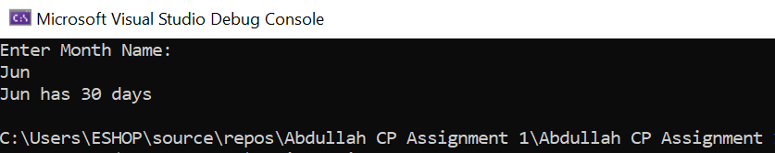
Question No 03: Write a C# program that takes integer between 1 and 12 from user and displays the name of the month using switch-case.
Solution:
Input:
using System;

namespace Abdullah_CP_Assignment_1
{
class Program
{
static void Main(string[] args)
{
int num;
Console.WriteLine("Enter Month Number (Between 1-12):");
num =Convert.ToInt32(Console.ReadLine());
switch (num)
{
case 1:
Console.WriteLine("{0}st Month is January",num);
break;
case 2:
Console.WriteLine("{0}nd Month is February", num);
break;
case 3:
Console.WriteLine("{0}rd Month is March", num);
break;
case 4:
Console.WriteLine("{0}th Month is April", num);
break;
case 5:
Console.WriteLine("{0}th Month is May", num);
break;
case 6:
Console.WriteLine("{0}th Month is June", num);
break;
case 7:
Console.WriteLine("{0}th Month is July", num);
break;
case 8:
Console.WriteLine("{0}th Month is August", num);
break;
case 9:
Console.WriteLine("{0}th Month is September", num);
break;
case 10:
Console.WriteLine("{0}th Month is October", num);
break;
case 11:
Console.WriteLine("{0}th Month is November", num);
break;
case 12:
Console.WriteLine("{0}th Month is December", num);
break;
default:
Console.WriteLine("{0} is out of the Range!", num);
break;
}
}
}
}
Output:
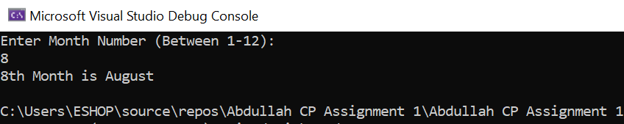
Question No 04: Write a C# program to check if the given year is a leap year or not. (A year may be a leap year if it is evenly divisible by 4 .Years that are divisible by 100 (century years such as 1900 or 2000) cannot be leap years unless they are also divisible by 400)).
Solution:
Input:
using System;

namespace Abdullah_CP_Assignment_1
{
class Program
{
static void Main(string[] args)
{
int year;
Console.WriteLine("Enter The Year:");
year = Convert.ToInt32(Console.ReadLine());
if (year % 4 == 0 || year % 400 == 0)
{
Console.WriteLine("{0} is a Leap Year.", year);
}
else
{
Console.WriteLine("{0} is Not a Leap Year", year);
}
}
}
}
Output:
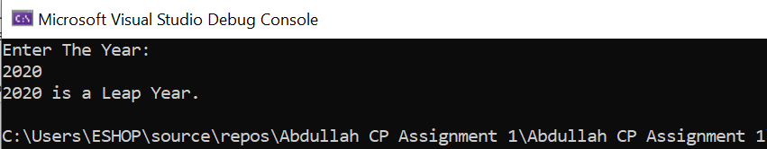
Question No 05: Write a C# program to check if given triangle is right angle triangle, acute angle triangle or obtuse angle triangle.
Solution:
Input:
using System;

namespace Abdullah_CP_Assignment_1
{
class Program
{
static void Main(string[] args)
{
double angle;
Console.WriteLine("Enter the Greatest Angle of the Given Triangle:");
angle = Convert.ToDouble(Console.ReadLine());
if (angle == 90)
{
Console.WriteLine("It's a Right Angle Triangle");
}
else if (angle >= 90)
{
Console.WriteLine("It's an Abtuse Angle Triangle");
}
else if (angle == 60)
{
Console.WriteLine("It's an Equilateral Triangle");
}
else if (angle <= 60)
{
Console.WriteLine("Invalid Input! {0} is not the Greatest Angle of Triangle", angle);
}
else if (angle <= 90)
{
Console.WriteLine("It's an Acute Angle Triangle");
}
}
}
}
Output:
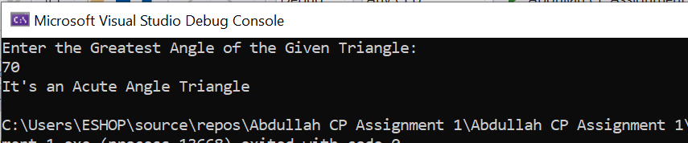
Question No 06: Write a C# program to print an appropriate message for Go, Stop and Wait on the bases of traffic lights by taking color of light as input.
Solution:
Input:
using System;

namespace Abdullah_CP_Assignment_1
{
class Program
{
static void Main(string[] args)
{
string lightColor;
Console.WriteLine("What is the color of traffic signal?");
lightColor = Console.ReadLine();
switch (lightColor)
{
case "Red":
Console.WriteLine("Please Stop Your Vehicle!");
break;
case "Yellow":
Console.WriteLine("Please Wait until Signal turns Green.");
break;
case "Green":
Console.WriteLine("Signal is Open, you may go.");
break;
default:
Console.WriteLine("Invalid Color!");
break;
}
}
}
}
Output:
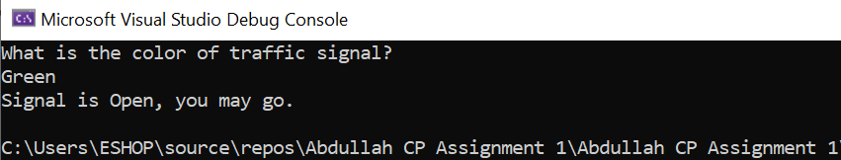
Question No 07: Write a C# program to calculate discount for a departmental store. The departmental store has two types of customers: 1) Walk-in customers 2) Registered customers. For registered customers, they are offering 5% discount if their monthly transaction is more than Rs.100000 and 5.5% discount if their monthly transaction is more than Rs.200000, otherwise they will get a discount of 3.5%. For Walk-in customers a 2% discount is available if the transaction amount is more than 50,000.
Solution:
Input:
using System;

namespace Abdullah_CP_Assignment_1
{
class Program
{
static void Main(string[] args)
{
double totalBill;
double monthlyTransaction;
double discount;
double finalBill;
string customerType;

Console.WriteLine("\t-Cashier Counter-");
Console.WriteLine("\nPlease Enter Your Total Bill (in Rs):");
totalBill = Convert.ToDouble(Console.ReadLine());
Console.WriteLine("Are You Registered Customer or Walk in Customer of our Store? (R for Registered / W for Walk in):");
customerType = Console.ReadLine();
if (customerType.Equals("R") || customerType.Equals("r"))
{
Console.WriteLine("Enter Your Monthly Transacted Amount in Our Store:");
monthlyTransaction = Convert.ToDouble(Console.ReadLine());
if (monthlyTransaction >= 200000)
{
discount = 0.055 * totalBill;
finalBill = totalBill - discount;
Console.WriteLine("Your Final Bill is {0} Rs with Discount of {1} Rs (5.5%) as You Are Our Registered Customer and Have Monthly Transaction of {2} (More Then 200000 Rs)", finalBill, discount, monthlyTransaction);
}
else if (monthlyTransaction >= 100000)
{
discount = 0.05 * totalBill;
finalBill = totalBill - discount;
Console.WriteLine("Your Final Bill is {0} Rs with Discount of {1} Rs (5%) as You Are Our Registered Customer and Have Monthly Transaction of {2} (More Then 100000 Rs)", finalBill, discount, monthlyTransaction);
}
else
{
discount = 0.033 * totalBill;
finalBill = totalBill - discount;
Console.WriteLine("Your Final Bill is {0} Rs with Discount of {1} Rs (3.5%) as You Are Our Registered Customer", finalBill, discount);
}
}
else if (customerType.Equals("W") || customerType.Equals("w"))
{
Console.WriteLine("Enter Your Monthly Transacted Amount in Our Store:");
monthlyTransaction = Convert.ToDouble(Console.ReadLine());
if (monthlyTransaction >= 50000)
{
discount = 0.02 * totalBill;
finalBill = totalBill - discount;
Console.WriteLine("Your Final Bill is {0} Rs with Discount of {1} Rs (2%) as You are Walk in Customer and Have Monthly Transaction of {2} (More Then 50000 Rs)", finalBill, discount, monthlyTransaction);
}
else
{
discount = 0 * totalBill;
finalBill = totalBill - discount;
Console.WriteLine("Your Final Bill is {0} Rs with Discount of {1} Rs", finalBill, discount);
}
}
Console.WriteLine("\n-Have a Nice Day-");
}
}
}
Output:
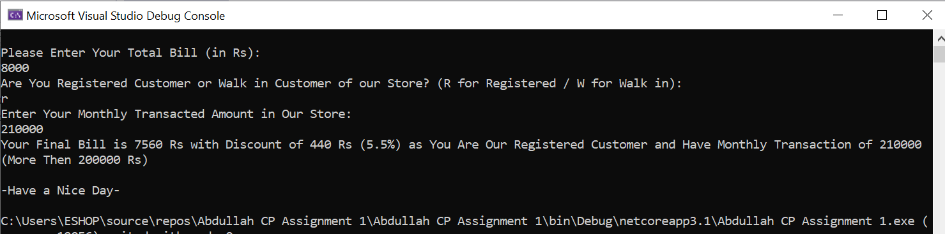
Question No 08: Write a C# program to calculate the total fee of a student of Bahria University (@ Rs.5000 per credit hour). There is a 50% discount for students from a naval background, a 20% discount for students with a sibling already studying in Bahria University and a 30% discount for Bahria University permanent employees.
Solution:
Input:
using System;

namespace Abdullah_CP_Assignment_1
{
class Program
{
static void Main(string[] args)
{
double creditHours, totalFee, discount, FinalFee;
int ratePerhour = 5000;
string studentBackground;
Console.WriteLine("\t-Student Semester Fee Calculator BUKC-");
Console.WriteLine("\nEnter Total Credit Hours of Your Program in this Semester:");
creditHours = Convert.ToDouble(Console.ReadLine());
Console.WriteLine("Enter your Background (Press 1 for 'Naval Background', 2 for 'Sibling Already Studying in Bahria', 3 for Bahria University Permanent Employees):");
studentBackground = Console.ReadLine();
totalFee = ratePerhour * creditHours;

if (studentBackground.Equals ("1"))
{
discount = totalFee * 0.5;
}
else if (studentBackground.Equals ("2"))
{
discount = totalFee * 0.2;
}
else if (studentBackground.Equals ("3"))
{
discount = totalFee * 0.3;
}
else
{
discount = totalFee * 0;
}
FinalFee = totalFee - discount;
Console.WriteLine("Your Fee is {0} Rs for this Program.", FinalFee);
}
}
}
Output:
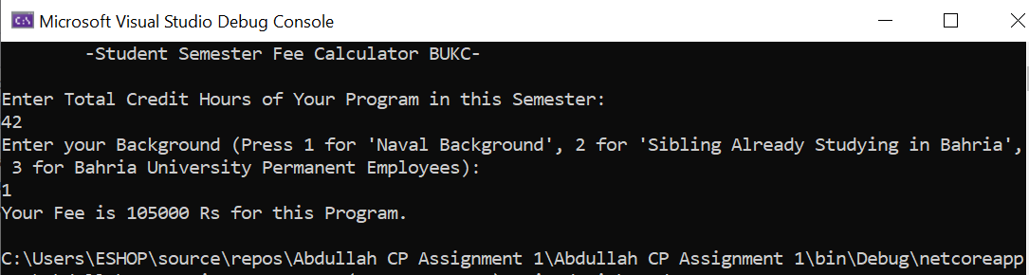
Question No 09: Write a C# program for user account login for userid = “admin” and password = “123456” (check userid and password).
Solution:
Input:
using System;

namespace Abdullah_CP_Assignment_1
{
class Program
{
static void Main(string[] args)
{
string userid = "admin";
string useridin;
string password = "123456";
string passwordin;
Console.WriteLine("\t-Account Login-");
Console.WriteLine("Enter User ID:");
useridin = Console.ReadLine();

if (useridin == userid)
{
Console.WriteLine("Enter Password:");
passwordin = Console.ReadLine();
if (password == passwordin)
{
Console.WriteLine("-Login Completed-");
}
else
{
Console.WriteLine("Invalid Password!");
}
}
else
{
Console.WriteLine("Invalid User ID!");
}
}
}
}
Output:
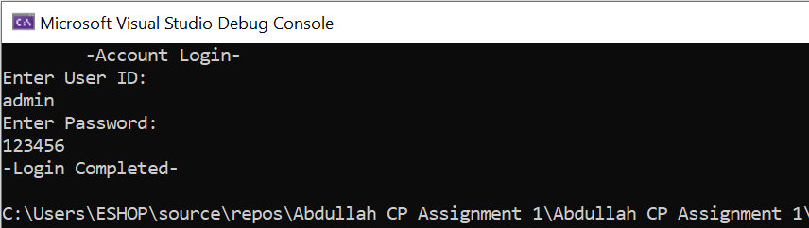
Question No 10: Write a C# program to check if given alphabet is a vowel or not.
Solution:
Input:
using System;

namespace Abdullah_CP_Assignment_1
{
class Program
{
static void Main(string[] args)
{
string v;
Console.WriteLine("Enter an Alphabet:");
v = Console.ReadLine();
if (v == "a" || v == "e" || v == "i" || v == "o" || v == "u")
{
Console.WriteLine("{0} is a Vowel.", v);
}
else
{
Console.WriteLine("{0} is not a Vowel.", v);
}
}
}
}
Output:
